**Description**

***WELCOME TO MVQuiz***

This app contains puzzles about popular movies in theater.

There are a lot of categories based on genres, actors, years.

The Objective of this app is providing knowledge for people who are interested in movies as well as test their memories about movie scenes.

*HOW TO PLAY*

Player has to guess the movie by typing the name of the movie from the movie scene.

*GAMEPLAY*

* + A lot of movie puzzles - Easy to play.
  + Have great fun with knowledge test.

**Market Search of My App:**

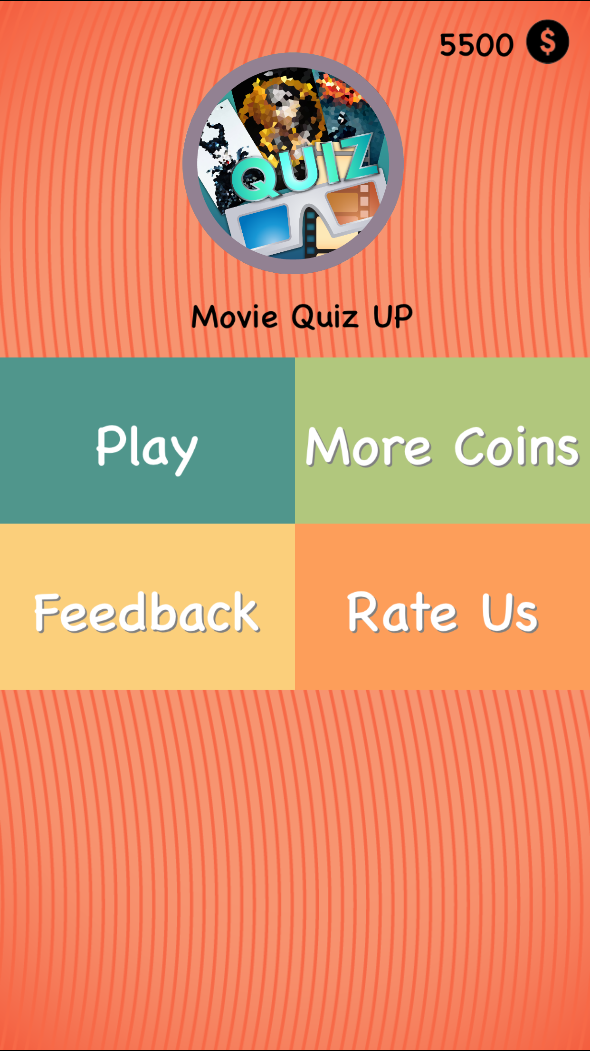****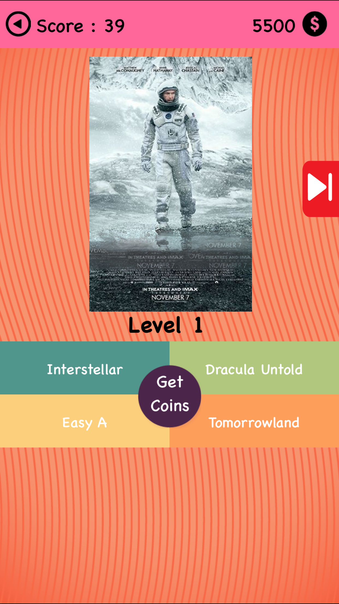**[Movie Quiz Up](https://itunes.apple.com/ru/app/movie-quiz-up-fim-knowledge-trainer/id997202067?l=en&mt=8)**

**[Movie Quiz](https://itunes.apple.com/us/app/movie-quiz-cinema-guess-what-is-the-movie/id690753620?mt=8)**

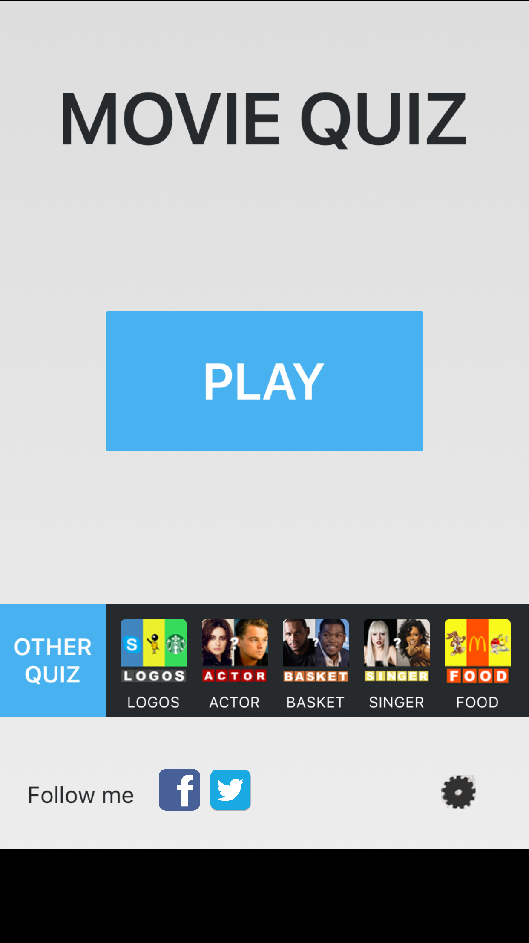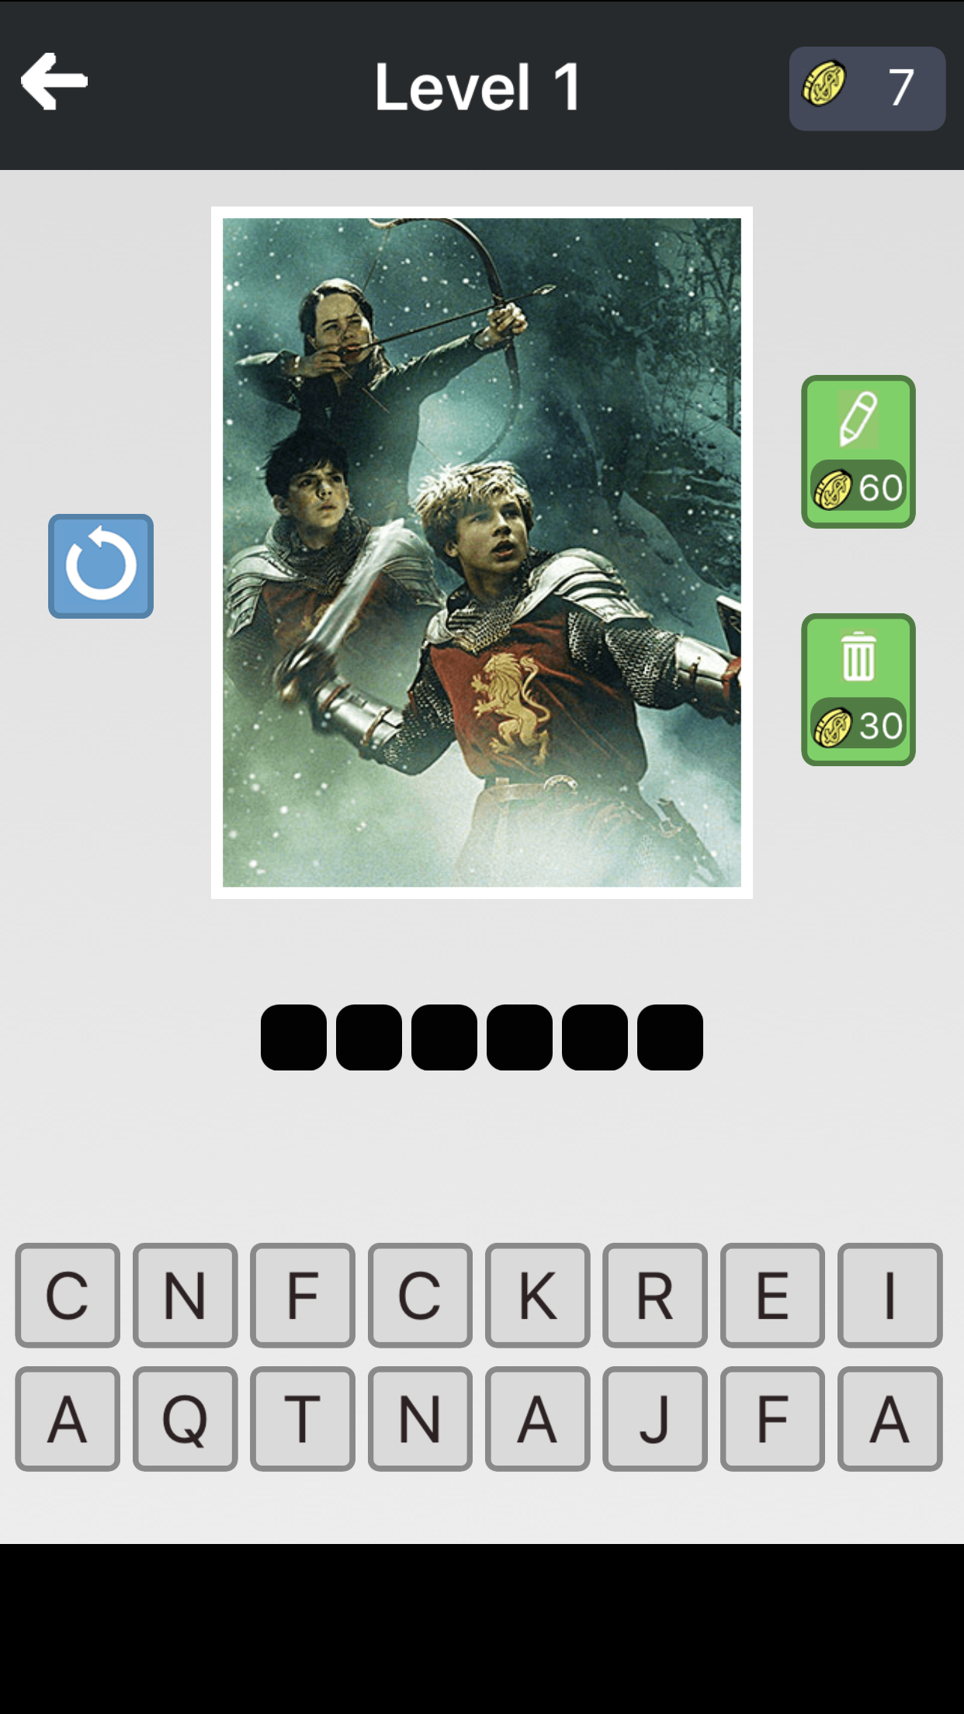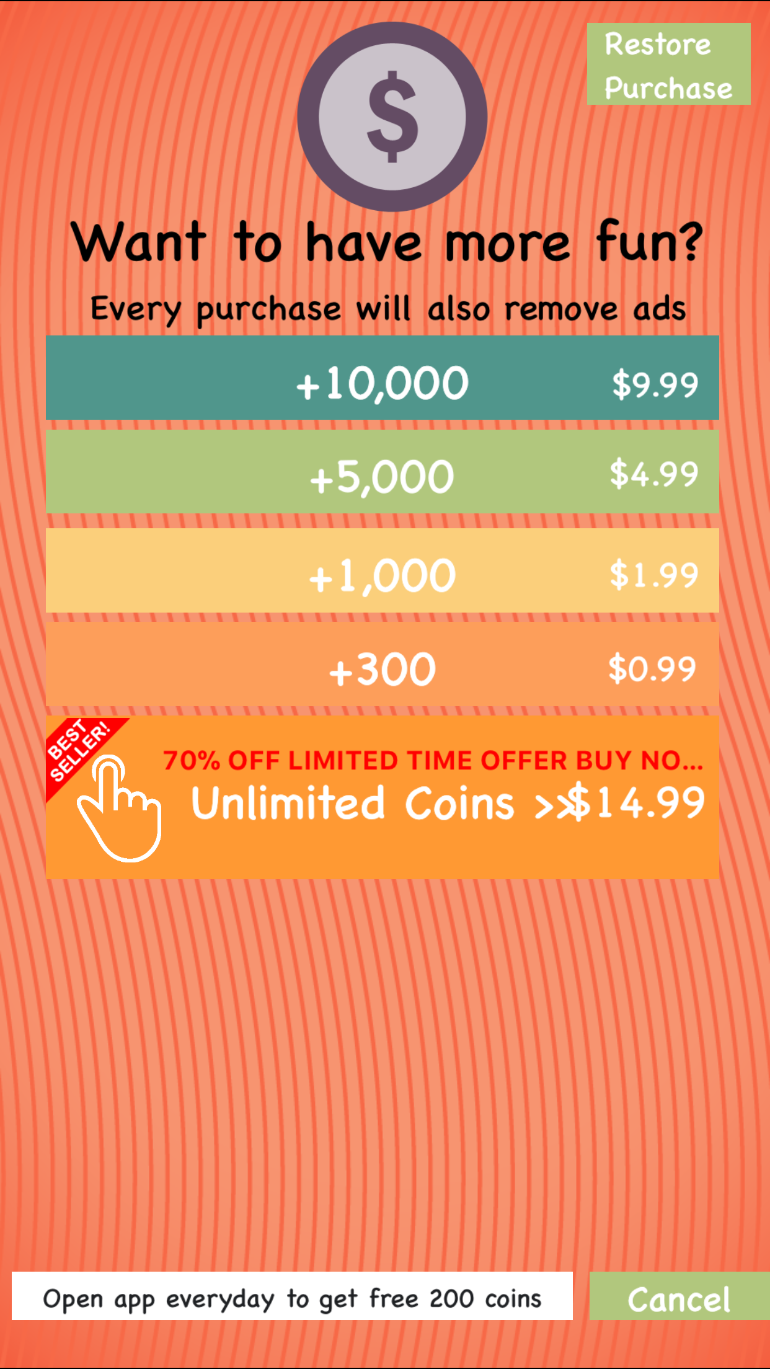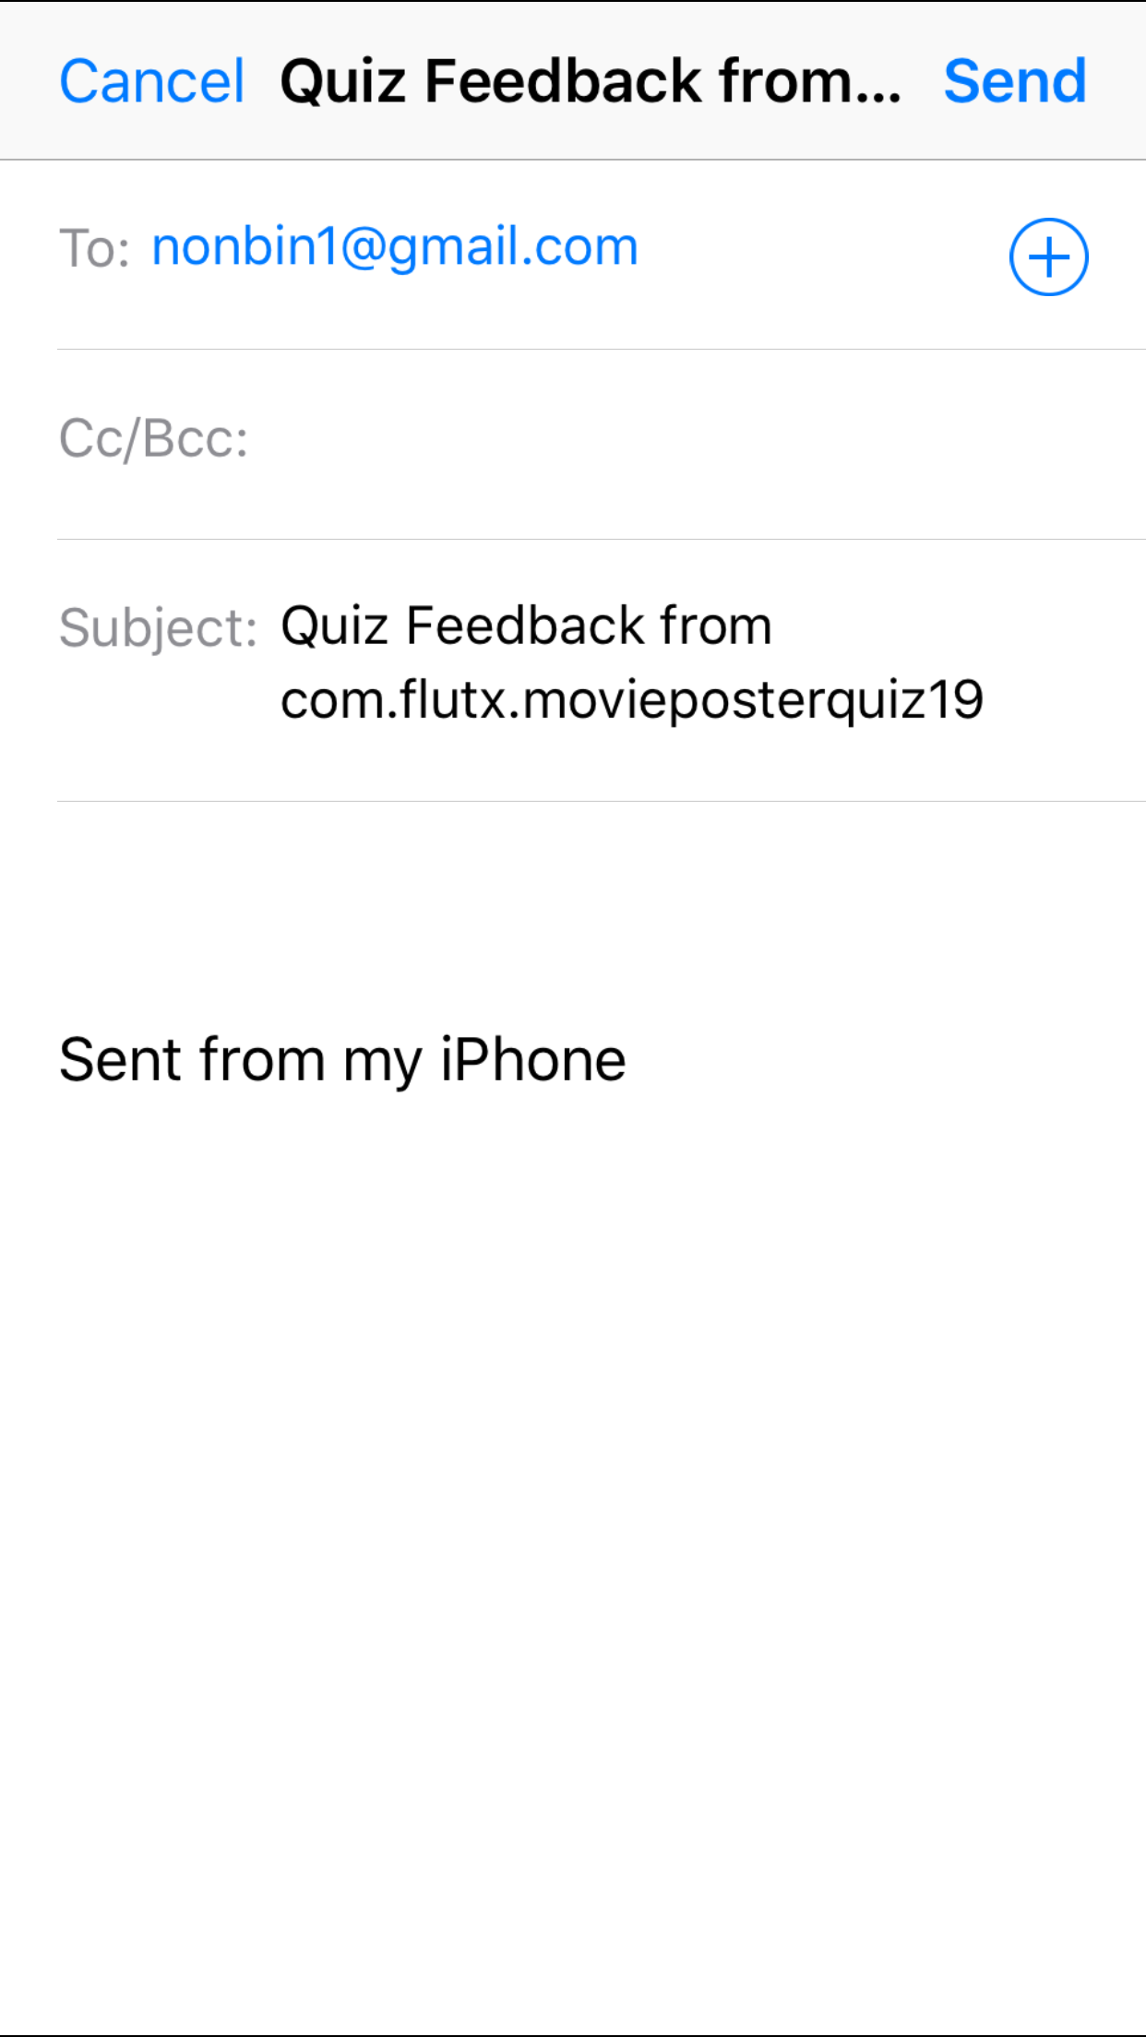

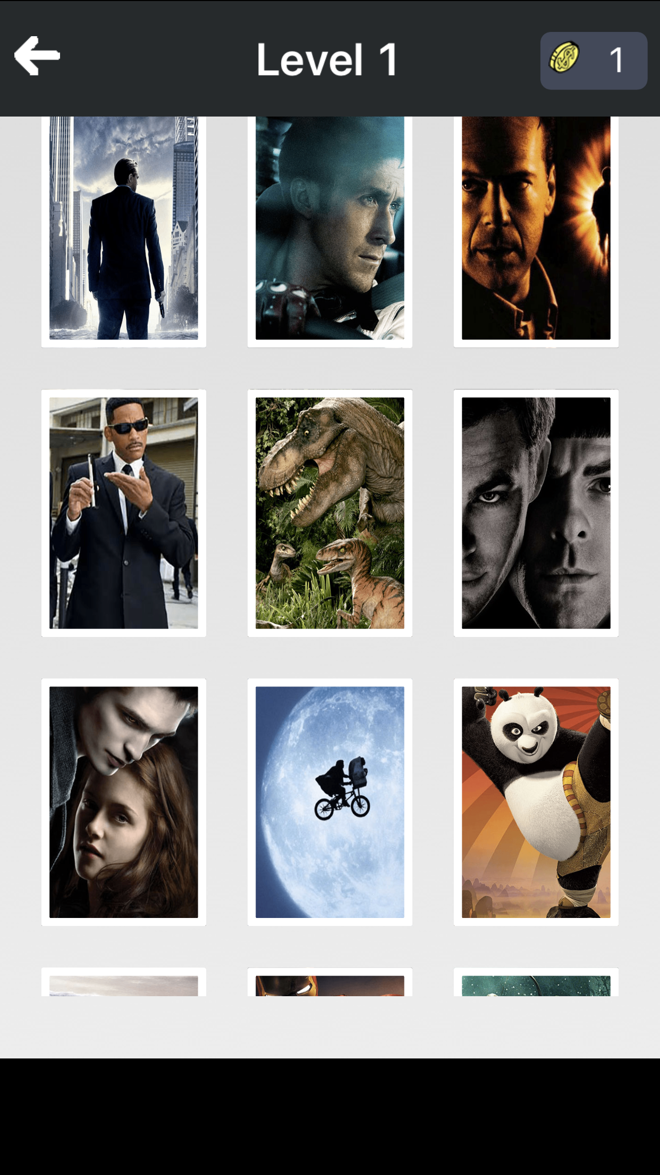

**[Guess The Movie](https://itunes.apple.com/us/app/guess-the-movie-pop-quiz-trivia-guessing-games/id801957884?mt=8)**

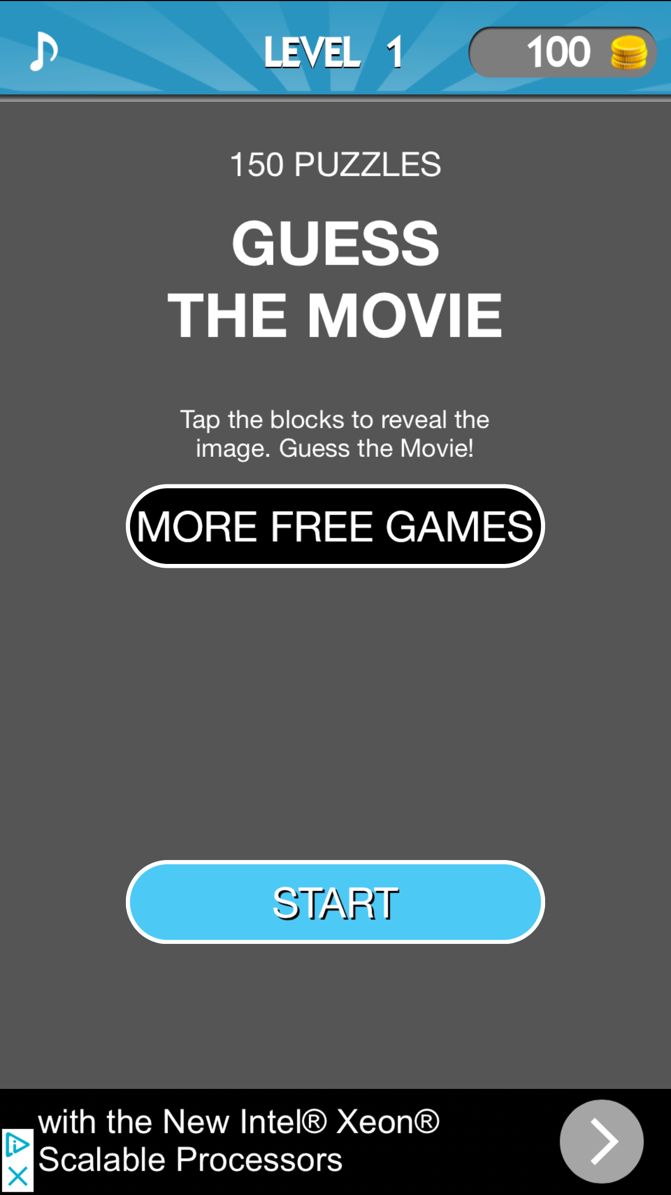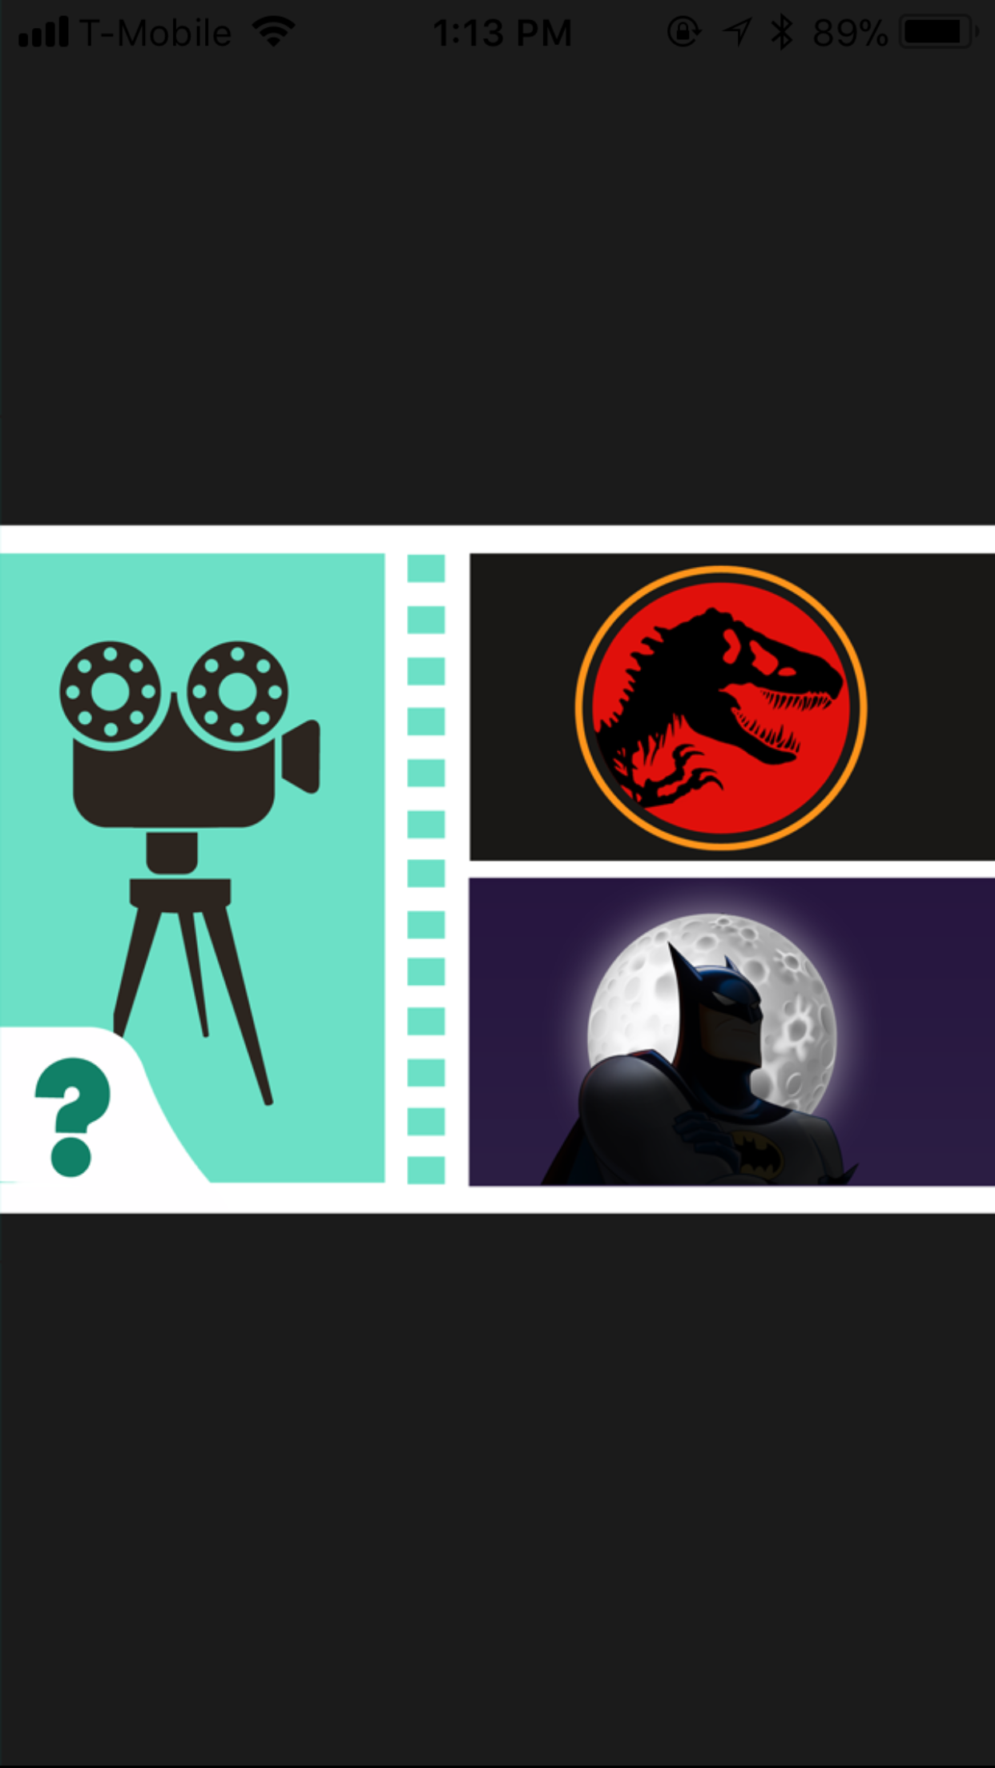

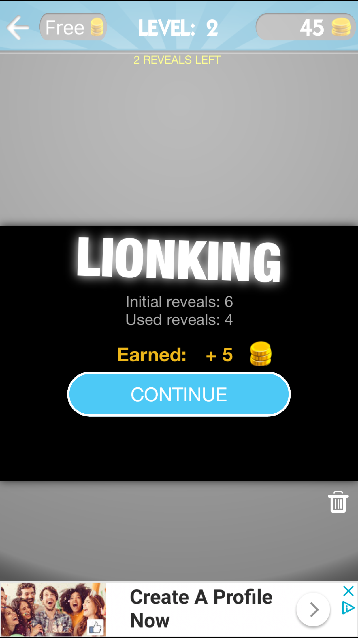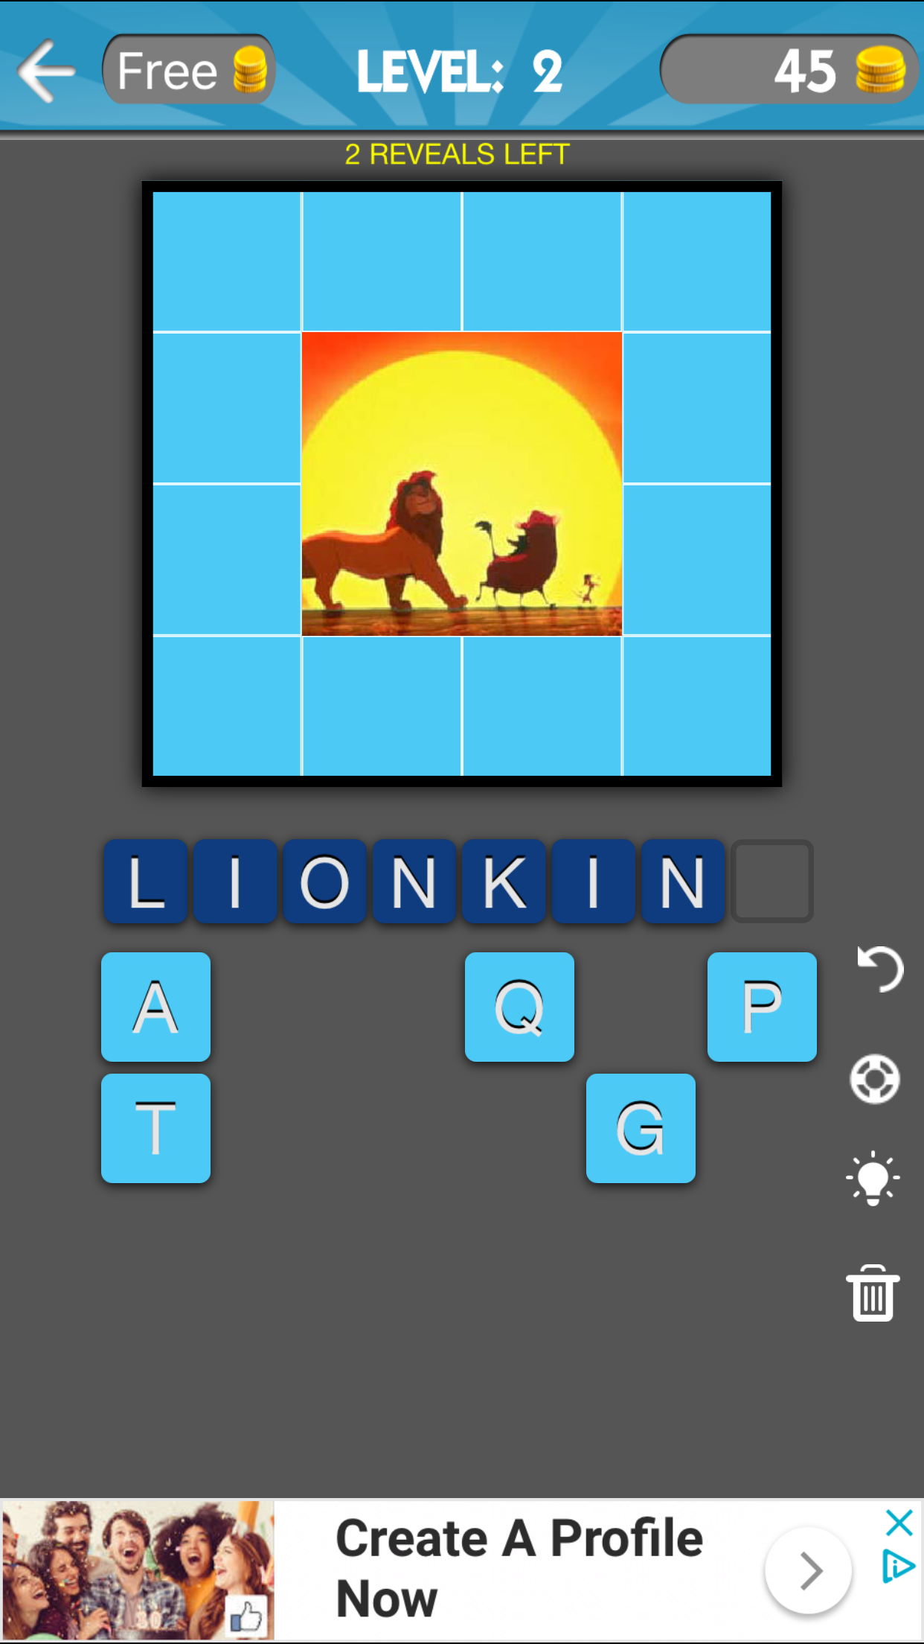

**DESIGN OF MY APP**

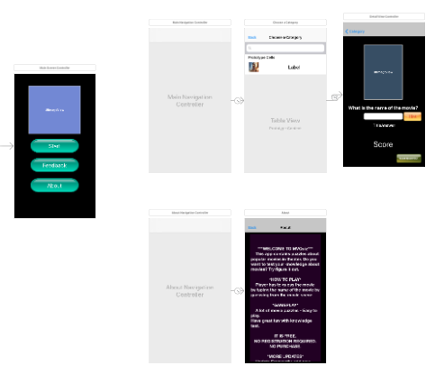

**Screenshot**

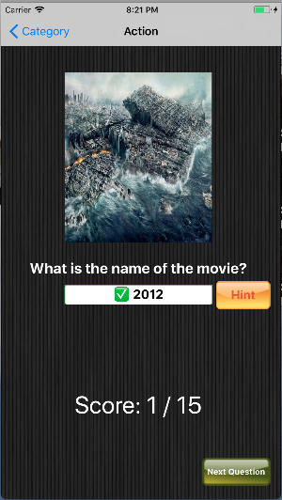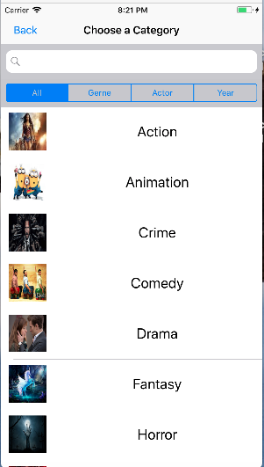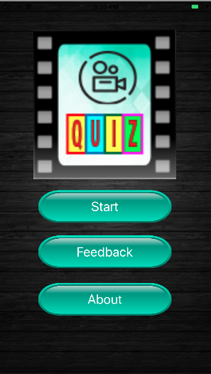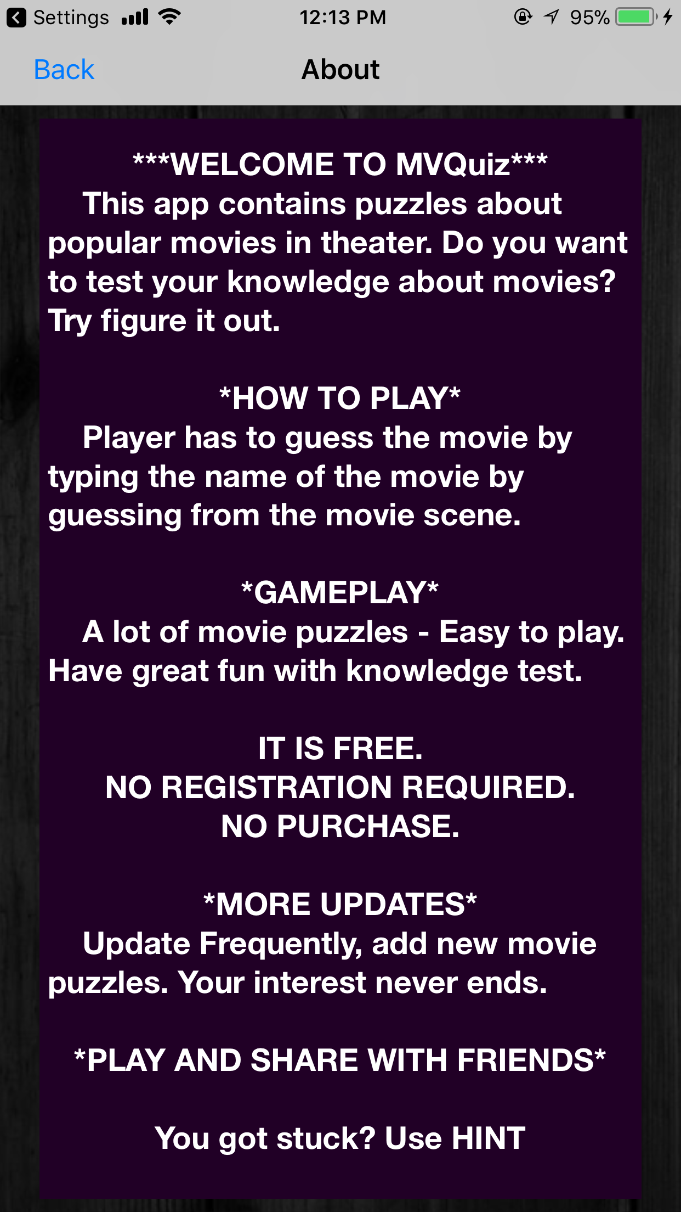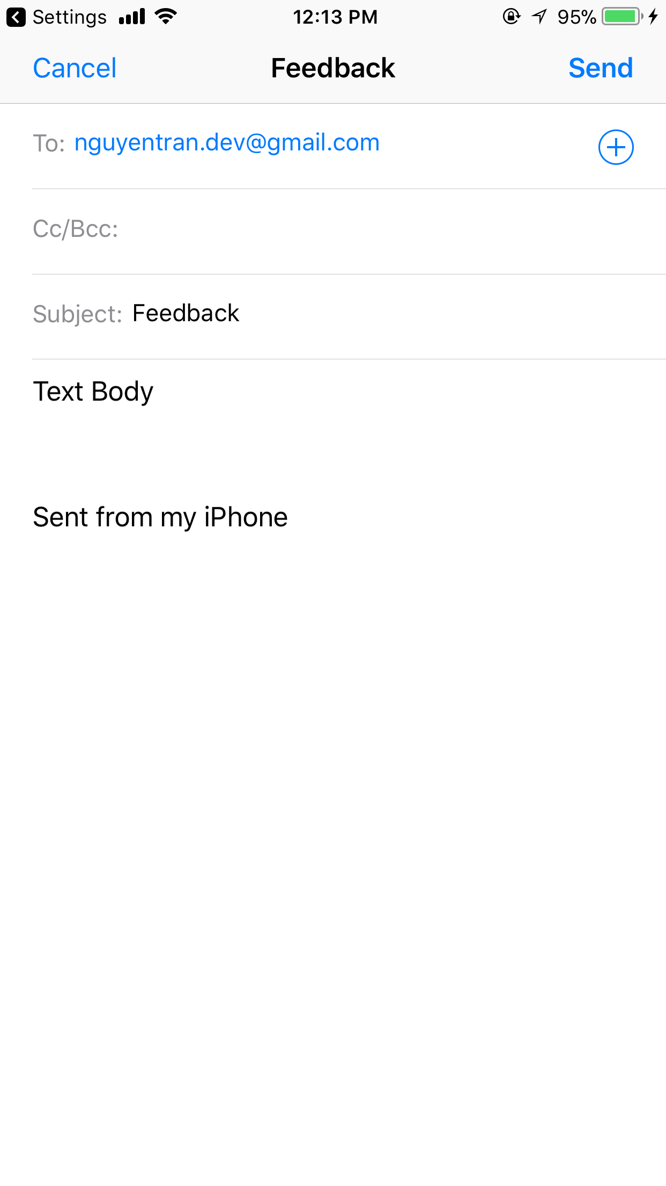

**Technology**

* UITextView, UITableViewController, UISearchBar, Text Input and Delegation, Navigation Bar Controllers, MFMailComposeViewController, reading CSV file

**Purpose of Technologies Used**

* Reading CSV to load data and append to array
* Text Input and Delegation: text input from user
* UISearchbar: create search bar so that user can search category.
* UITextview: create a text view for a description
* UITableViewController: create category cells
* Navigation Bar Controllers: switch multiple screens
* MFMailComposeViewController: load Mail application to send mail for feedback

**Information on seller**

Nguyen Tran – Undergraduate student at Cal State University of Fullerton